Vector Dot Product
Why dot product uses multiplication + addition?
- vectorvisualizer.com
- vectorvis.com
- geogebra.org
It does two things at once:
- Multiplication → compares corresponding directions
- A_{x} x B_{x} : how much both vectors align in x-direction
- A_{y} x B_{y} : how much both align in y-direction
👉 If both point same way → positive
👉 Opposite → negative
👉 Independent → zero

- Addition → combines total alignment
We add contributions from all directions to get overall similarity

Seeing Numbers as Vectors
Let's start simple, and treat 3 x 4 as a dot product:
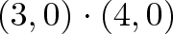
The number 3 is "directional growth" in a single dimension (the x-axis, let's say), and 4 is "directional growth" in that same direction. 3 x 4 = 12 means we get 12x growth in a single dimension. Ok.
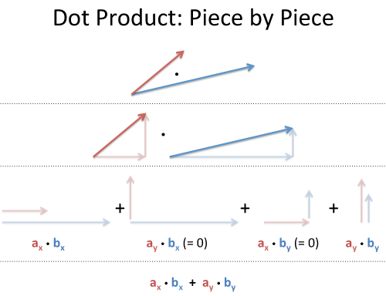

Geometric meaning
This gives similarity between vectors
- Small angle → similar direction → large dot product
- Small angle → similar direction → large dot product
- 180° → opposite → negative
Dot Product
Real-world Example
Example 1: Walking with wind
- You walk forward → vector A
- Wind blows → vector B
Dot product tells:
“How much wind is helping or opposing your movement”
- Same direction → helps (positive)
- Opposite → slows you (negative)
- Sideways → no effect (zero)

Example 2: Fuel efficiency in car
- Car direction → velocity vector
- Engine force → force vector
👉 Dot product = useful work done Work = F . d
- Same direction → maximum work
- Perpendicular → zero work

Example 3: Fuel efficiency in car
- Sunlight direction → vector B
- Solar panel direction → vector A
👉 Dot product = “How much sunlight actually hits the panel”

Example 4: Recommendation systems → similarity
Example 5: Light intensity in graphics
Example 6: Work done in physics

Why cosine, why not sine?
For two vectors:
- cos(θ) → “How much they point in the same direction” ✅
- sin(θ) → “How much they are different / perpendicular” ❌

Vector Cross Product
Gives a new vector:
- Perpendicular to both A and B
- Magnitude: |A x B| = |A||B|sin θ

Real-world Example
Example 1: Opening a door
- Force applied → vector A
- Distance from hinge → vector B
Cross product = Torque
τ = r×F
- Push straight → no rotation
- Push perpendicular → maximum rotation

Example 2: Rotating fan / wheel
- Direction of rotation = cross product direction
- Use right-hand rule

Dot vs Cross (simple intuition)
Concept | Dot Product | Cross Product
Meaning | Similarity | Rotation / perpendicular effect
Result | Scalar | Vector
Uses | Work, projection, similarity | Torque, rotation, area
Angle dependency | cosθ | sinθ

Netflix Recommendation
Problem:
intex | Movie Type
1 | Action
2 | Sci-fi
3 | Romance

You watched:
- Action movies ✔
- Sci-fi ✔
- Romance ❌
System needs to recommend next movie.

Step 1: Convert user & movies into vectors
User vector U=(5,4,0)
Means:
- 5 → loves Action (very high interest)
- 4 → likes Sci-fi (moderate interest)
- 0 → no interest in Romance
Movie A (Action + Sci-fi) A=(4,5,1)
Movie B (Romantic) B=(0,1,5)

Step 2: Compute similarity (dot product logic)
User vs Movie A:
U⋅A=(5×4)+(4×5)+(0×1)=20+20+0=40
👉 High similarity
…………………………………………………………………………………………………………………………………………….
User vs Movie B
U⋅B=(5×0)+(4×1)+(0×5)=0+4+0=4
👉 Very low similarity

Step 3: Normalize (cosine similarity)
Movie = (4,5,1)

Dot Product Result:
𝑈1⋅𝐴 = 40
U2​⋅A = 400
👉 System thinks: User 2 is 10x better match ❌ (WRONG)
Why?
- To remove bias of large numbers
- Final result between -1 and 1
Example:
- User 1: U₁=(5,4,0)
- User 2: U₁=(50,40,0)
👉 Both have same preference pattern
………………………………………………………………………………
What’s the real issue?
Solution → Cosine Similarity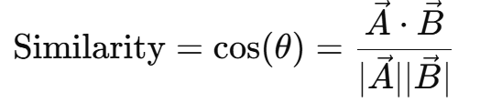
- ✔ Direction (taste)
- ❌ Magnitude (activity level)

Users | Dot Product | Cosine Similarity
U₁ vs A | 40 | ~0.98
U₂ vs A | 400 | ~0.98
👉 Now both users are treated equally similar ✅

Represent words as vectors
Word | Vector (Gender, Royalty, Age)
king | (-1, 1, 1)
queen | (1, 1, 1)
man | (-1, 0, 1)
woman | (1, 0, 1)
boy | (-1, 0, 0)
girl | (1, 0, 0)
prince | (-1, 1, 0)
princess | (1, 1, 0)
uncle | (-1, 0, 1)
aunt | (1, 0, 1)
paper | (0, 0, 0)
water | (0, 0, 0)
Royalty = people who rule or are born into ruling families
Assume each word has 3 features:
- Gender (Male = -1, Female = +1)
- Royalty (Common = 0, Royal = 1)
- Age (Young = 0, Adult = 1)

king + woman – man
king + woman = (0, 1, 2)
(king + woman) - man = (1, 1, 1)
👉 Result = (1, 1, 1) = queen
king = (-1, 1, 1)
woman = ( 1, 0, 1)
man = (-1, 0, 1)
✔️ So: king + woman - man ≈ queen
Dot product: (-1 * 1) + (0 * 0) + (1 * 1) = -1 + 1 = 0
👉 Similarity ≈ LOW (only common feature = "adult")

Intuition:
- Opposite gender → reduces similarity
- Same age → increases similarity

similarity(man, woman)
man = (-1, 0, 1)
woman = ( 1, 0, 1)

Closest vectors:
- queen → (1,1,1) ✅ (same royalty + age)
- prince → (-1,1,0) ✅ (same gender + royalty)
- man → (-1,0,1) ✅ (same gender + age)

most_similar(king, top 3)
We compare "king" with others.
king = (-1, 1, 1)

👉 So: most_similar(king) = [queen, prince, man]
Efficient Vector Search:
ANN (Approximate Nearest Neighbor
Algorithms)

How most_similar works? Does it scan all vectors?
- Compute similarity (usually cosine similarity)
- Compare with all vectors (words)
- Sort results

king – man
king - man = (0, 1, 0)
👉 Meaning: "Royalty" feature only
✔️ Interpretation: Difference between king and man = "royal status"
king = (-1, 1, 1)
man = (-1, 0, 1)

woman – man (1,0,1) - (-1,0,1) = (2,0,0) 👉 Meaning: pure gender difference

norm(vec1 - vec2)
man - woman = (-2, 0, 0)
Norm: √((-2)^2) = 2
👉 Larger value = more different

This tells how far two words are

distance(man, woman) = 2
distance(king, queen) = 2

